Assignment 13.1
2403A51341
Task-1:
Prompt:Give code for this code more efficient Code
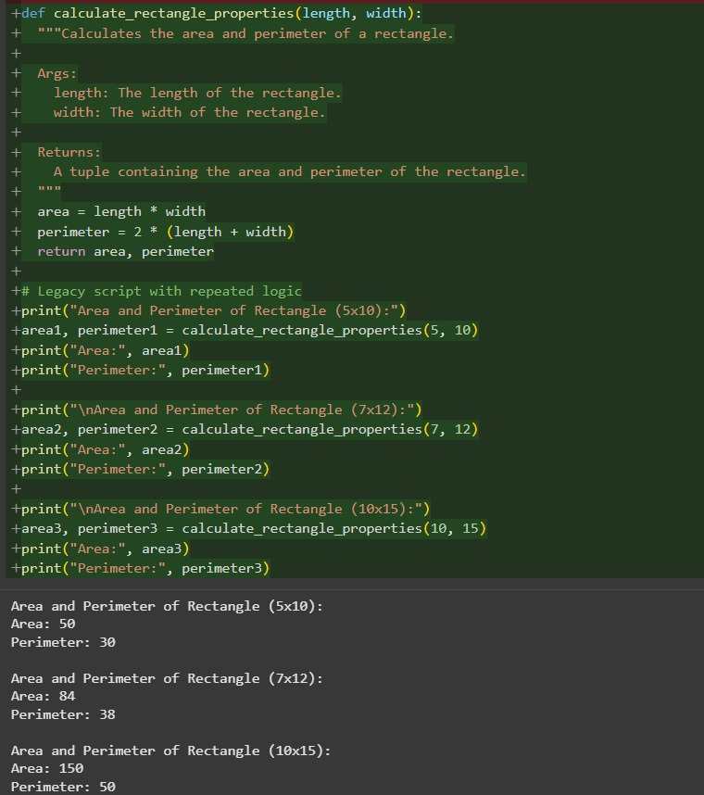
Code and Output:

Observation: we can see that the Code is Optimized by the AI

Task-2:
Prompt: Improvise the given code
Code and Output:
Given Code:
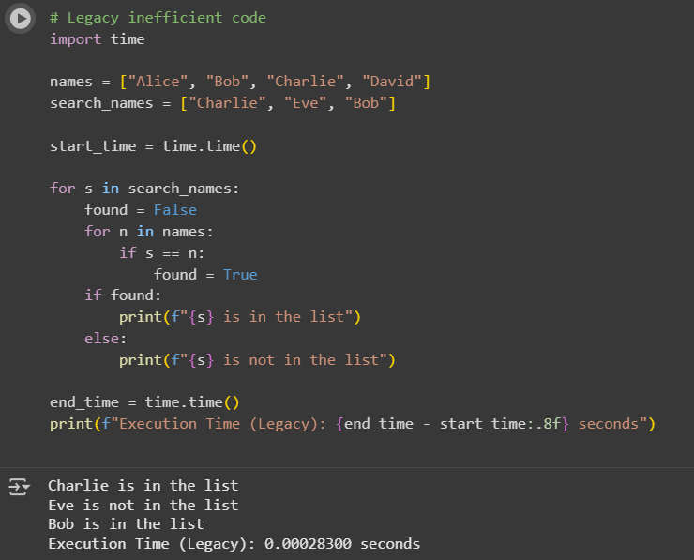
Improvised code:
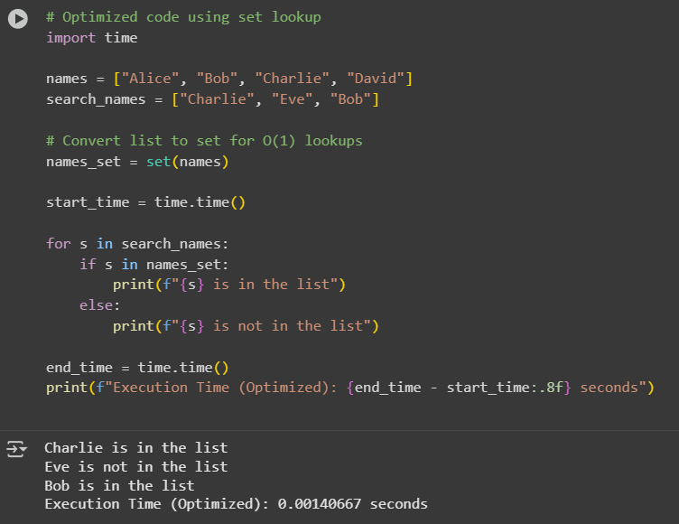
Observation: We can Observe That the code is improvised by the AI

Task-3:
Prompt:Refactor the given Code
Code and Output:
Before Refactoring:
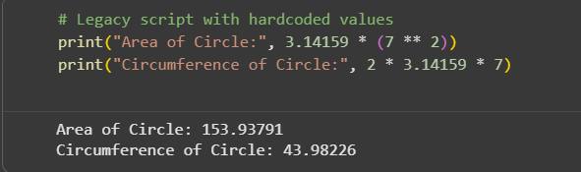
After Refactoring:
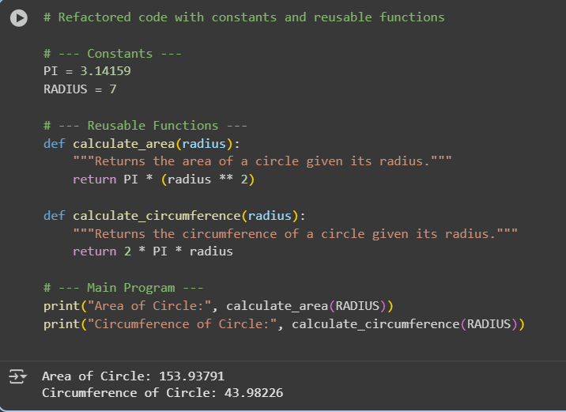
Observation:
In this question we can Observe that the Code is Refactored by the AI

